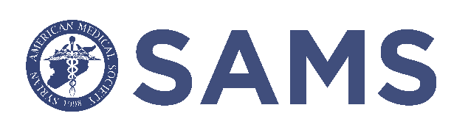

SAMS 6th NATIONAL SYMPOSIUM
“Innovations and Transformations in Healthcare”
PRELIMINARY SCIENTIFIC PROGRAM
*Subject to change

SCHEDULE OF EVENTS:

FRIDAY 2/17/2023
6:00PM – 9:00PM: Opening Ceremony & Reception

SATURDAY 2/18/2023
7:30AM – 8:30AM: Breakfast
8:30AM – 10:30AM: Scientific Program
10:30AM – 11:00AM: Coffee Break
11:00 AM – 1:00PM: Scientific Program
1:00PM – 1:45PM: General Body Meeting
1:45PM – 2:15PM: Sponsored Lunch
7:00PM – 11:00PM: Gala Dinner

SUNDAY 2/19/2023
11:00AM – 4:00PM: Picnic in the Park Social

PRELIMINARY SCIENTIFIC PROGRAM
SEPTEMBER 3rd, 2022

WELCOME

SESSION 1

START – END | LECTURE TITLE: | SPEAKER:
8:30 AM – 9:00 AM | SAMS Catheterization Lab in Idlib: Progress and Plans for Expansion | Zaki Lababidi, MD
9:00 AM – 9:30 AM | The Burden of Cardiovascular Disease in Subsaharan Africa | Blair Suter, MD
9:30 AM – 10:00 AM | Revolutionizing Cancer Treatment with the Use of Immunotherapy | Ghassan Saed, MD
10:00 AM – 10:30 AM | Using Molecular Testing for the Non-Hematologist in Practice | Aref Alkali, MD

10:30 AM – 11:00 AM | Coffee Break

SESSION 2

START – END | LECTURE TITLE: | SPEAKER:
11:00 AM – 11:30 AM | Treating Resistant Depression & Advances in Mental Health Therapeutics | Khaled Bowarshi, MD
11:30 AM – 12:00 PM | Advancements in Minimally Invasive Urology | Nabeel Hamoui, MD
12:00 PM – 12:30 PM | Exploring Intelligent Systems in Medical Informatics | Taha Kass-hout, MD
12:30 Pm – 1:00 PM | The Role of Simulation in Medical Education | Abdulghani Sankari, MD PhD

